**Web Development Internship**

# Internship Report

**Submitted by:** Palak Jain

**Enrollment No.:** 21103196

***Bachelors of Technology, Computer Science and Engineering***

***Jaypee Institute Of Information Technology***



***Department Of Computer Science and Engineering***

***June – July 2024***

# Title: E-Voting Platform for Trusts & NGO’s

* **Company/Organisation's Name and Address:** Cube Software Pvt. LTD, Nodia
* **Mode of Internship –** Hybrid
* **Name and Designation of Training In-charge:** Mr. Nirupam Kumar Sinha, Director
* **Period of Training:** 31 May 2024 – 31 July 2024

* **Name, Department, and Enrollment No. of the Student:**

Palak Jain, 21103196

Department of Computer Science and Engineering

* **Name of the Institute:** Jaypee Institute of Information Technology

# Table of Contents

* Acknowledgement

* Declaration

* Introduction

* Description of the Industry/Organisation/Company

* Description of the Work Carried Out

* Details of Data Collection, Analysis, Program Development

* Results

* Conclusion

* References
* Appendices

# Acknowledgement

I would like to express my deepest gratitude to **Cube Software Pvt. Ltd.** for providing me with this invaluable internship opportunity. It has been an immensely rewarding experience that has allowed me to grow both professionally and personally. The exposure to real-world projects and cutting-edge technologies has significantly enriched my learning journey.

I extend my heartfelt thanks to my mentor, Mr. Nirupam Kumar Sinha, for his unwavering guidance, support, and mentorship throughout the project. His expertise and insights have not only helped me tackle complex challenges but also inspired me to push my boundaries and think innovatively. His feedback and encouragement have been instrumental in shaping the successful outcome of this project.

I would also like to acknowledge the constant support and encouragement of my faculty and peers at Jaypee Institute of Information Technology. Their valuable advice and collaboration have been essential in fostering a conducive environment for my growth and development. Their contributions, no matter how small, have played a significant role in my success during this internship. This opportunity has been a stepping stone in my career, and I am truly grateful to everyone who has contributed to this enriching experience.

# Declaration

I, Palak Jain, hereby declare that the work presented in this internship report, titled "E-Voting Platform for Trusts and NGO’s" is an original work conducted by me during my internship at Cube Software Pvt. Ltd, from May 31, 2024, to July 31, 2024. The content of this report is based on my understanding, research, and the tasks I performed under the guidance of my mentor. This report has not been submitted to any other institution for the award of any degree or diploma.

# Introduction

The objective of this project is to develop an online voting system that facilitates the conduct of elections for various organizations, such as societies or trusts. The platform will enable professionals, representing these organizations, to efficiently manage the election process for different positions within their respective institutions.

Through this platform, any professional seeking to organize elections can register and initiate the necessary procedures. These registered individuals, referred to as professionals, will have the exclusive authority to set up and administer elections for the organizations they represent. Once registered, each professional will be responsible for managing all aspects of the elections, ensuring a secure and transparent voting process under their profile.

This system aims to streamline the election process, making it accessible, user-friendly, and adaptable to the needs of diverse organizations.

# Description of the Industry/Organisation/Company

Founded in 1991, Cube Software Private Limited specializes in manufacturing and providing technology solutions such as Autodialer Software, Voice Logger, IVRS, Call Billing Software, Voicemail Systems, CRM Systems, and Conference Bridge Services. Known for professionalism and reliability, the company also offers services like Mobile Logger and Call Centre Solutions.

With corporate offices in Noida, New Delhi, Mumbai, and Kolkata, and support offices in Chandigarh, Cube Software is well-positioned to deliver tailored solutions across India. The company has formed partnerships with leading firms like Avaya and Panasonic, allowing it to meet client needs efficiently.

Cube Software's products and services are trusted by major organizations, including IRCTC, Yatra, Fortis Hospital, Wipro, Hero Honda, and the Indian Armed Forces, along with over 1,000 other companies. The company's aim is to simplify business tasks and enhance operational efficiency for its clients.

# Description of the Work Carried Out

The project involves the development of an online voting system using a Django backend and a React frontend, with MySQL Workbench as the database management tool. The system is designed to allow organizations to conduct elections efficiently and securely.

Key tasks completed during the project include:

1. **Backend Development (Django):**

* Created the core application logic, including user authentication, election creation, candidate management, and vote tallying.
* Implemented APIs to handle data flow between the frontend and the backend.
* Configured security measures to ensure data integrity and user privacy.

1. **Frontend Development (React):**

* Developed a user-friendly interface for professionals to register, set up elections, and monitor results.
* Implemented interactive components for the voting process, allowing voters to select and submit their votes seamlessly.

1. **Database Management (MySQL Workbench):**

* Designed and structured the database to store information related to users, organizations, elections, candidates, and votes.
* Ensured efficient data retrieval and management for both large and small-scale elections.

1. **Documentation:**

* Prepared comprehensive documentation, including system architecture, database schema, API specifications, and user manuals for easy understanding and future maintenance.

This integrated system provides a scalable and secure platform for conducting online elections.

# Details of Data Collection, Analysis, Program Development

1. **Data Collection:**

* **User Data:** Data was collected from registered users, including professionals setting up elections and voters participating in the election process. This data includes user credentials, organization details, and role-specific information (e.g., election organizers vs. voters).
* **Election Data:** Information such as election titles, candidate names, election timelines, and voting preferences were collected. This data is essential for generating accurate election results.
* **Voting Data:** Collected votes from each voter in real-time, ensuring that each user can cast only one vote per election. Voting data was encrypted to maintain anonymity and integrity.

1. **Data Analysis:**

* **User Activity Monitoring:** Analysed user interactions to ensure smooth functionality, detect anomalies, and prevent multiple voting attempts. Logged voting patterns to ensure integrity and security.
* **Election Results:** Implemented algorithms to accurately tally votes and generate results in real-time. Data was analyzed to detect any irregularities, such as duplicated or tampered votes, ensuring a fair election process.
* **Data Integrity Checks:** Periodic audits and validation checks were carried out to ensure the consistency and reliability of data stored in the MySQL database, with a focus on minimizing redundancy and improving retrieval speed.

1. **Program Development:**

* **Backend (Django Framework):** The backend was developed using Django to handle user authentication, election setup, and voting processes. It included API endpoints for managing CRUD operations (Create, Read, Update, Delete) for elections, users, and candidates. The backend also handled vote tallying and secured database interactions.
* **Frontend (React Framework):** The frontend was built with React, providing an interactive and intuitive user interface. Key features include responsive design, real-time vote casting, and dynamic updates to reflect election statuses. React components were designed to handle API requests and render results efficiently.
* **Database (MySQL Workbench):** The database schema was designed to handle complex relationships between users, elections, and votes. MySQL Workbench was used to design and implement normalized tables that ensured data integrity, minimized redundancy, and optimized query performance.
* **Security Measures:** Implemented secure authentication using Django’s built-in user authentication system, alongside encryption protocols to safeguard voting data and personal information. SSL encryption was enforced for all communications between the client and server.
* **Documentation:** Comprehensive documentation was prepared to explain the system architecture, database schema, APIs, and code structure. This includes technical and user documentation for both developers and end-users to ensure easy system deployment and maintenance.

This structured approach to data collection, analysis, and program development ensures that the online voting system is secure, reliable, and scalable for organizations to use efficiently.

# Results

The online voting system developed using Django, React, and MySQL Workbench successfully met its objectives by providing a secure, user-friendly platform for conducting elections. Professionals can easily register, create elections, and manage candidates, while voters can participate seamlessly. The system ensures data integrity with secure authentication, encryption, and role-based access control, delivering a transparent and efficient voting process.

# Conclusion

My internship experience has been profoundly enriching, providing me with valuable insights into both the practical and technical aspects of software development. Working on the online voting system project has been particularly rewarding, allowing me to apply and expand my skills in Django, React, and MySQL Workbench. The project not only honed my technical abilities but also enhanced my understanding of real-world application development, from user interface design to backend integration and data security. This hands-on experience has significantly contributed to my professional growth and prepared me for future challenges in the tech industry.

# References

* V Bhavan, L. Koli, L. Rishi, & Reddy, M. S. (2022). Online voting system. *International Journal for Engineering and Technology Research*. Retrieved from <https://www.academia.edu/download/88184154/Online_Voting_System.pdf>
* Mehta, M., Lalwani, M., & Harle, A. (2022). Online voting system. *Journal for Research in Applied Science and Engineering Technology*. Retrieved from <https://www.academia.edu/download/86869503/Online_Voting_System.pdf>
* Singh, B., Ranjan, K. S., & Aggarwal, D. (2020). Online voting system. *Journal of Research in Industrial Engineering*, *7*(1), 22-34. Retrieved from <https://www.riejournal.com/article_120678_aa8dfb0efaa125acb41317b2b1534a5c.pdf>
* Forcier, J., Bissex, P., & Chun, W. J. (2008). *Online voting system project using Django*. Retrieved from <https://books.google.com/books?hl=en&lr=&id=M2D5nnYlmZoC&oi=fnd&pg=PT21&dq=online+voting+system+project+using+django&ots=v_UJIt7RKR&sig=IjzNnyYIMxgISDcjZrqL5SULswA>

# Appendices

* Appendix A: Source Code

* Appendix B: Admin Dashboard and Outputs

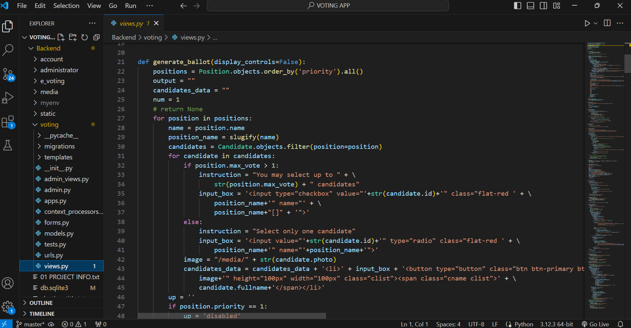

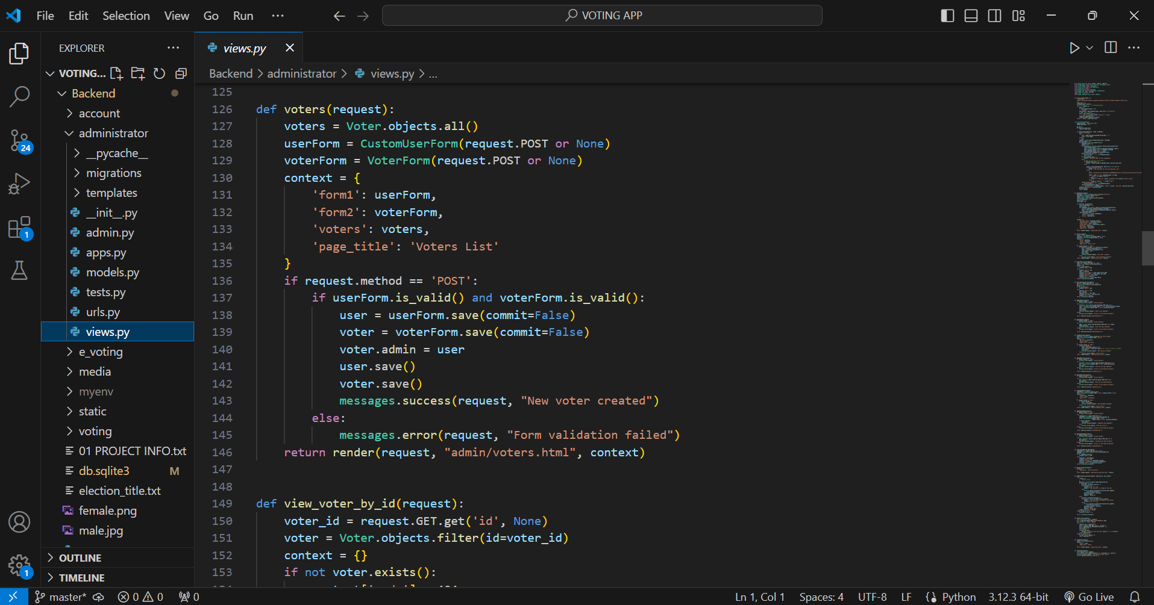

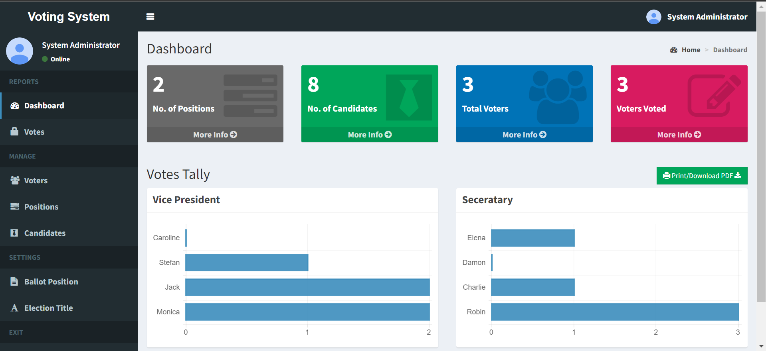

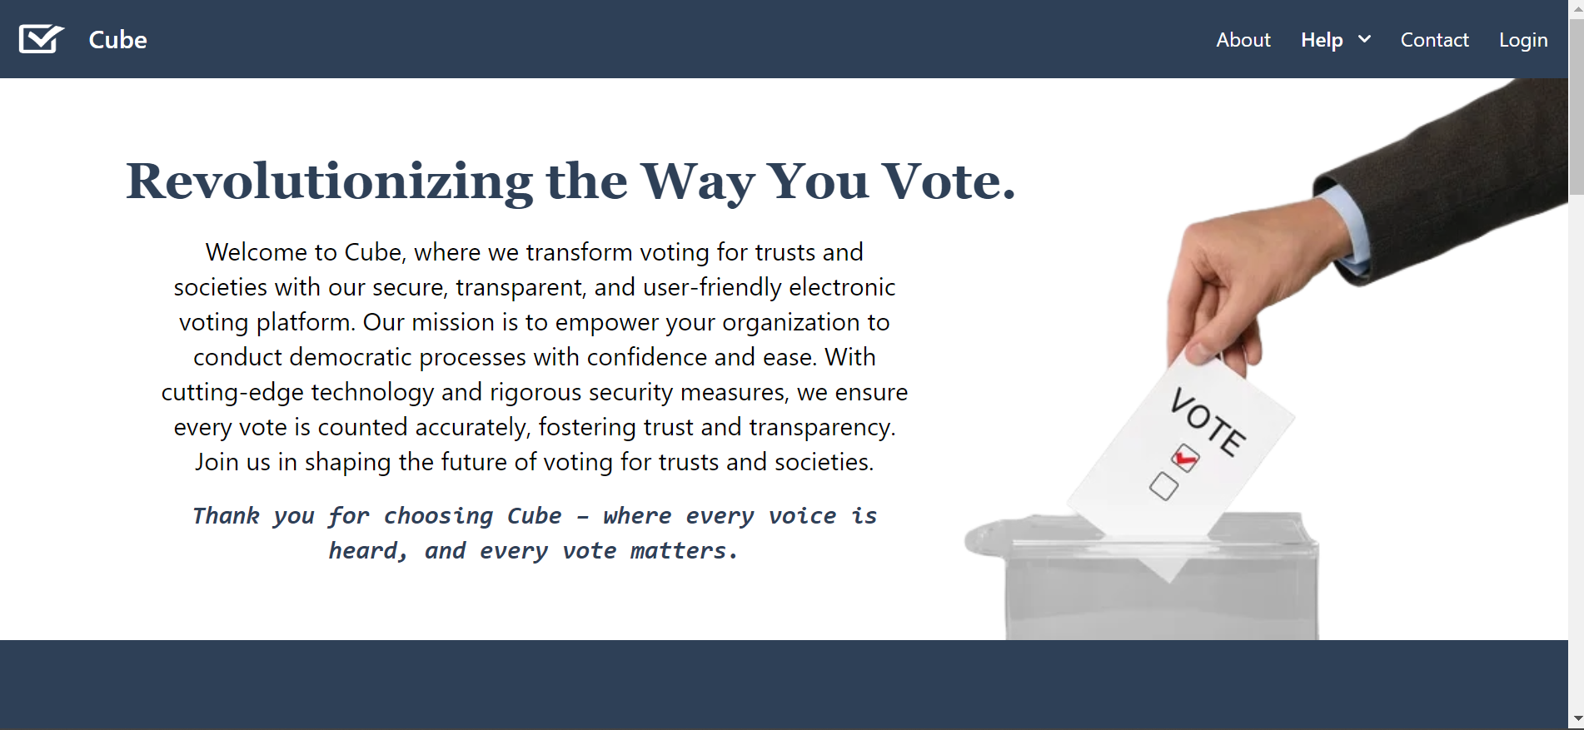

# Internship Certificate

